Dear Hirers, **April 2025**

I wanted to update you on the changes taking place with our facility hire for April. With the recent managerial transition, we are wanting to confirm bookings throughout April and May. Please email and confirm your dates with us.

**Invoicing**

We are changing our booking system slightly and all bookings from April will be paying in arrears. Please note all payment terms will still be strictly 14 days from date of invoice. If there are continued late payments this may result in existing discounts or agreements being removed.

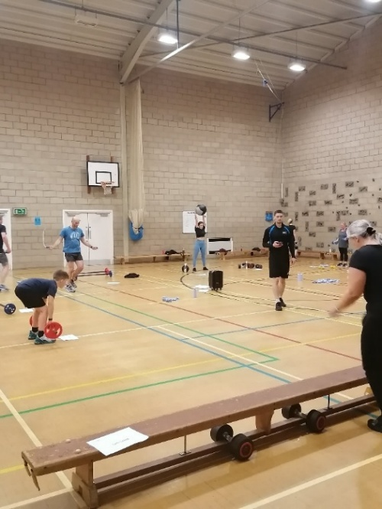**Reminder of exams**

**The unavailable dates are as follows:**

**Tuesday 6th may 2025 – Sunday 25th may 2025**

**Monday 2nd June 2025 – Friday 27th June 2025**

# **CUSTOMER BENEFITS**

Don’t forget as a Block Booking Customer all your clubs’ coaches, players, parents & staff over 18 can get access to our Corporate Partner Discounts. This is now available online on all our membership packages. All potential members need to do is use the Promo code: **CORPORATE10** and then we verify their eligibility with you the hirer. This is an additional perk in hiring the facilities at 3d Wey Valley.

Kind regards,

Emily Seymour

Club Manager